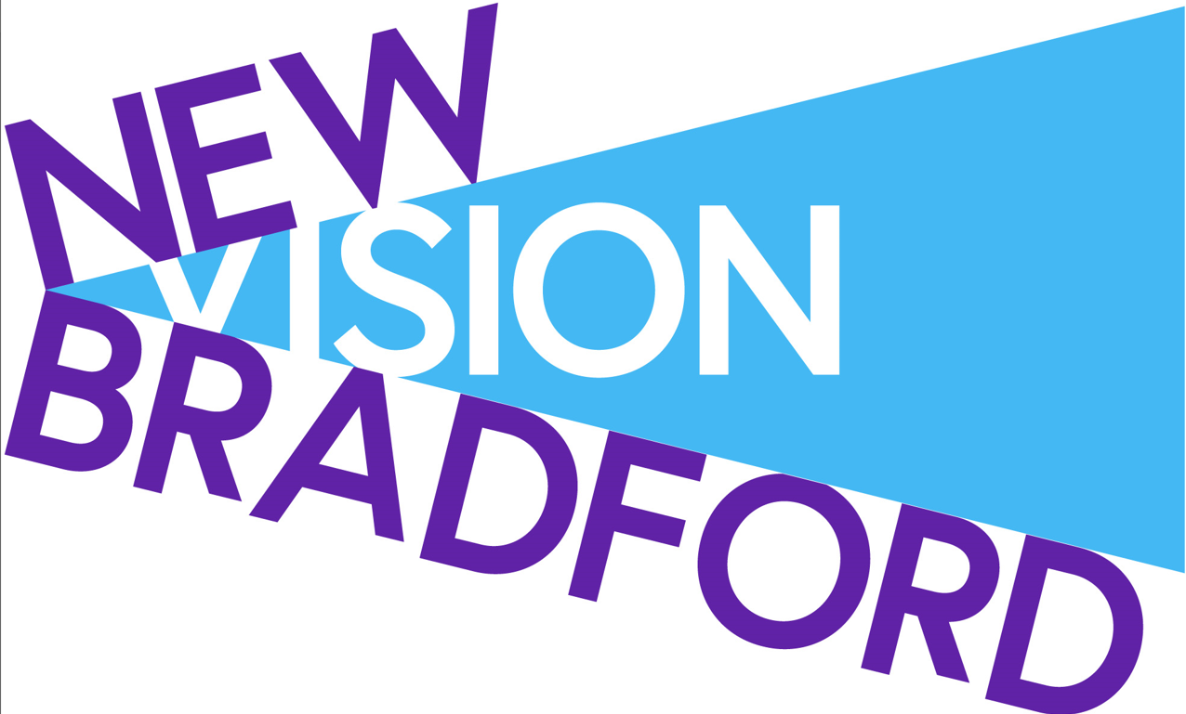

Empowering people experiencing multiple barriers to achieve positive change.

Job Description

Title: Activities Coordinator

Location: New Vision Bradford, Bradford/ Airedale - all service site locations.

Responsible to: Team Leader

Salary Scale: SCP 11 £25,920

Hours of Work: 37.5 hours, nominally Mon, Wed, Thur, Fri – 9:15-5:15 (including 30min unpaid lunch break), Tuesday – 12-8pm (including 30min unpaid lunch break) with flexibility according to service need.

ROLE PURPOSE
New Vision Bradford offers a range of support for people experiencing issues with substances from across Bradford, Keighley, Bingley, Ilkley, Shipley and everywhere in the district.
This role is a new and exciting position, working with Team Leader and overseeing volunteers to coordinate and deliver recovery activities, trips and events at Flourish community Coffee Shop and Recovery Hub.

The successful candidate will have a passion for recovery, be energetic, pro-active and confident in co-producing activities and events. We would welcome applicants with a particular skill in activities such as art, music or fitness but this is not a requirement of the role.

Key Duties and Responsibilities
- Support the development of service-based recovery communities.
- Co-production of events and activities with service users and volunteers
- Coordinate volunteer participation in leading activities and events
- Identify recovery focused activities, trip, events
- Identify and develop relationships with partners that can enhance offer of activities/ events in the community.
- Develop links with local recovery groups / mutual aid groups.
- Ensure the timely and accurate collection, recording and reporting of specified data.
- Assess suitability for groups in terms of risk and service user needs.
- Carry out risk assessments and risk management.
- To be creative and innovative so that the post best meets the needs of the service user, promoting access into treatment, and continued engagement with underrepresented communities.
- Ensure that all aspects of confidentiality are adhered to and that consent to share information is a key element to building trusting therapeutic alliances.
- Help individuals to develop recovery resources and access peer and mutual support groups to develop their own recovery capital.
- Comply with all monitoring and evaluation systems, collect, and monitor information as appropriate and provide reports when required and actively contribute to the Partnership achieving successful outcomes for service users.
- Reduce substance related harm to the individual and wider community.
- Coordinate, participate and review activities, trips and events.
- Contribute to the effective preparation, monitoring and review of individual recovery plans.
- Undertake continuing professional development including participating in supervision, performance reviews and attending training as/when required.
- Work in accordance with all relevant legislation, policies and procedures and guidelines – both internal and external. This includes Humankind’s clinical governance framework and relevant Bridge operational policies and procedures.
- Keep abreast of policy and professional development within your area of professional expertise.
- To promote, adhere to and live our workplace values of being honest, committed, and inventive.

Person Specification | Essential | Desirable
Qualifications | A relevant professional qualification (eg NVQ3 in Health and Social Care, Social Work Degree, RMN, etc)  or  2 years full time or equivalent in part time experience of working with people with alcohol and / or drug problems and/ or people with complex and multiple needs within the last 4 years. | Qualification in relative field for activities (eg Art, music, fitness, wellbeing)
Experience | Relevant experience of delivering activities in a community setting  Experience of working in an outcomes-focussed environment.  Experience of updating and maintaining records in a timely fashion and working to deadlines for the submission of information, e.g. reports.  Experience of liaising and work in partnership with a wide range of professionals and agencies. | Experience of designing and delivery of group work interventions in line with a recognised therapeutic model.
Knowledge and Skills | Excellent understanding of drug and alcohol issues.  Has a good working knowledge of adult and child safeguarding.  Accomplished written and verbal communication skills and a high degree of personal IT competency.  Excellent time management skills, and an ability to work on own initiative, prioritising accordingly.  Excellent team working and interpersonal skills, maintaining a highly cooperative approach to supporting colleagues in delivering service objectives.  Ability to manage change successfully in a way that prioritises the needs of service users.  Ability to communicate complex information to individuals and groups in a way that is easily understood.  Effective interpersonal skills with the ability to engage successfully with internal and external stakeholders at all levels.  The ability to work collaboratively with others (internally and externally). | Good working knowledge of mental health interventions, services and good practice.
Other attributes | A commitment to multi-agency working and establishing partnerships with other professions to achieve good outcomes for the service user group, e.g. mental health services, criminal justice agencies, community groups, etc.  The post holder is expected to be flexible with regards to working hours in order to meet the requirements of the post.  Willingness to contribute to the training and development of others.  Demonstrable experience of working flexibly, positively, and cooperatively within a team.  Willingness to work within a performance managed  environment and contribute to performance reporting.  Willingness to undertake regular supervision and appraisal and comply with relevant local policies with regards to personal conduct and performance

