

Empowering people experiencing multiple barriers to achieve positive change.

Job Description

Title of post: Volunteer and Training Coordinator

Location: All Service Site Locations/Bradford

Responsible to: Team Leader

Salary Scale: £27,756-£30,288 (dependant on skills and experience)

Hours of Work: 37.5 per week Mon-Fri - 9:15-5:15pm with 30min unpaid break
each day.

Recovery Volunteer scheme overview

The post holder has responsibility for recruiting, training and supporting Recovery Volunteers, Recovery Supporters, Mentors and Trainees/ Volunteers for New Vision Bradford. The post holder works in close partnership with the Flourish team with a central and overarching philosophy to promote visible recovery throughout the organisation, demonstrating that people can and do recover from substance misuse.

This post holder will provide, deliver and/or quality control accredited qualifications at level 1 and 2, within the social care sector primarily to, but not exclusively for, individuals in recovery from substance misuse. Courses are typically delivered to around 25 learners with a high completion and accreditation rate and are offered a number of times a year. The organisation works with a local college provider in the delivery of our accredited programmes and has also achieved direct access qualification status enabling internal accreditation of portfolios by the post holder and other suitability qualified individuals.

The post holder works with Team Leaders to develop defined volunteering opportunities for graduates and also provides short 1-2 day courses to prepare / develop graduates for these roles. The majority of graduates of the scheme go on to take up defined roles in the service matched to their own interests, knowledge, skills and experience. Many graduates have also gone on to further education and also found full and part time employment.

Role purpose

To work in partnership to ensure that progression to mentoring, volunteering, training and recovery, is an obtainable and clearly visible transition for service users and to ensure that Recovery Volunteers and peer mentor are safely recruited in accordance with organisational standards, provided with suitable accredited training opportunities, matched and inducted to appropriate roles and supported throughout their placements.

The successful candidate will ensure all aspects of the day-to-day running of the Volunteer Service are delivered. This includes coordinating a large team of active peer mentors, volunteers and trainees/ volunteers to provide resources to New Vision Bradford.

To ensure Bridge staff, trustees, and recovery volunteers and peer mentors are kept aware of good practice in volunteering and of any changes in legislation that might impact on volunteering and to promote the work of the Volunteer Service internal and externally.

Volunteer Training Schemes

- Design, develop and keep under review, lesson plans for the organisation courses mapped to awarding bodies accredited qualifications for Recovery Volunteers and Peer Mentors.

Advertise and recruit suitable candidates for the various courses in accordance with Bridge’s recruitment policies and procedures and contractual performance.

- Provide a combination of Tutor delivery and Internal Quality Assurance activities for courses, ensuring timely portfolios sign off and application for awards.

- Flexibly support learners throughout the course to achieve graduation

Volunteer Service Provision

- To identify where volunteers can actively support the delivery of services.

- To work proactively across the service to ensure the role and value of peer mentors and volunteers are promoted and accessible at all stages of a service user’s journey.

- To promote, and recruit to, volunteering opportunities within Bridge New Vision Bradford, ensuring Bridge’s equal opportunities policy is upheld, and opportunities are accessible to individuals from a wide range of backgrounds.

- To develop and coordinate in-house and external training for peer mentors and volunteers which will enable them to contribute effectively, appropriately and safely to the delivery of activities and interventions and encourage service users to achieve support.

- To coordinate and support regular supervision of mentors and volunteers, ensuring that any student placements requirements are fulfilled, any problems are resolved, and volunteers are involved in meaningful and rewarding work.

- Ensure that all mentors and volunteers have clear roles and responsibilities, regular supervisions and personal development plans and goals.

- To support mentors and volunteers to build skills portfolios and gain certificates/qualification to evidence internal and external training, supported by further Education, Training and Employment (ETE) opportunities.

- To develop and coordinate appropriate peer mentor and volunteer policies and procedures.

- To record all peer mentor/volunteer activity documentation and notes to a high standard and within required time frames, and to contribute to reporting requirements.

- Ensuring Recovery Volunteers and Peer Mentors are appropriately matched for a suitable position.

- Raising staff awareness of the role and function of Recovery Volunteers and Peer Mentors.

- Organising rotas and providing inductions.

- Celebrating volunteering by nominating volunteers for awards and organising celebration and graduation events.

- Offering advice and information to volunteers and external organisations through face-to-face, telephone and email contact.

- Attending committees and meetings.

- Managing budgets and resources, including the reimbursement of expenses.

- Monitoring and evaluating activities and writing reports for funders and trustees.

- Review and update the training manual, protocols and operational procedures in relation to the running of the scheme to ensure that it maintains external accreditation.

- Monitor volunteer satisfaction and carry-out quality control measures.

- Support and encourage volunteer feedback across all services and planning structures.

Service Development

- To engage local stakeholders and community members through outreach and robust referral pathways into volunteering schemes.

- Working with multiple agencies across different sectors in order to establish good working relationships to influence decisions about volunteering.

- Organising profile-raising events to attract new volunteers.

- To compile monthly performance data on the number of volunteer hours and a quarterly costs/benefit analysis of volunteer activity.

Performance and personal management:

- To work flexibly to provide adequate cover for all aspects of the service.

- To work alongside and provide support and supervision to peer mentors and volunteers.

- To be responsible for performance management at an individual level through self-management; delivery of goals and tasks set; delivery of contractual requirements; targets and outcomes; and reporting progress.

- To performance manage volunteer programmes and interventions, for example regards activity data; engagement, retention and planned exit; outcomes (training, work, progression).

- To actively engage in opportunities for learning and development at an individual and team level.

- To comply with operational management systems of supervision, objectives, appraisal and induction.

- To comply with data collection procedures and reporting to ensure effective recording of performance monitoring, outcomes and service user information.

- To adhere to the implementation of risk management procedures (including child and adult safeguarding protocols) taking personal responsibility for keeping up to date with the requirements of these procedures.

General

- The post-holder must be able to relate to the ethos, aims and objectives of Bridge.

- To present a professional appearance, help maintain an orderly working environment, and act at all times to uphold the good reputation of Bridge Project.

- To ensure that all visitors to the service are welcomed in a responsive, helpful and professional manner.

- To proactively maintain professional knowledge and practice and attend, use and contribute to supervision and team meetings effectively.

- To work within professional boundaries maintaining safety and appropriate confidentiality at all times.

- To contribute to organisational initiatives as required.

- To demonstrate commitment to Bridge’s Mission, Vision and Values and strategy, ensuring that this informs and is embedded within service delivery and practice.

- To comply with all published Bridge policies and procedures.

- To work flexibly to undertake such other reasonable duties and responsibilities, at any location within reasonable daily travel from your main place of work.

The job description will be reviewed regularly and may be subject to change.
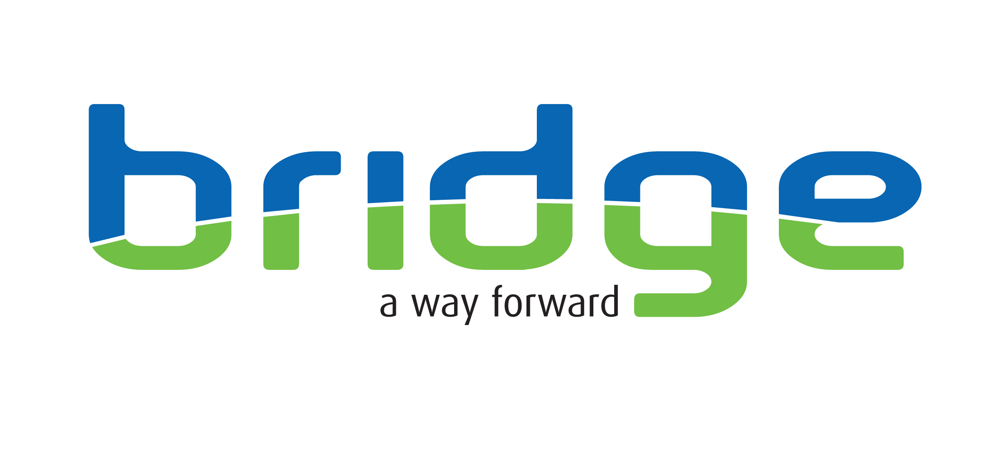
PERSON SPECIFICATION: Volunteer and Training Coordinator

 | Essential | Desirable | How demonstrated
Qualifications | - Tutor award: Cert Ed, PGCE, PTLLS, Level 3 award in education and training or equivalent  Or  - Verifier award: D32, D33, D34, A1, V1 or IQA award  Or  An equivalent educational certificate and training and/ education. |  | Certificates at interview
Experience | - 1 year’s full time or equivalent in part time experience within the last 3 years in development and delivery of volunteer/ mentoring and/or training programmes to adults.  - Demonstrable experience in the design and delivery of lesson plans and evaluation of training programmes within a group learning setting which achieve the desired impact.  - Experience of maintaining confidential records and providing information for monitoring and evaluation.  - Experience of positive liaising and working with professionals from a variety of disciplines.  - Experience and proficient in the use of MS Office Word, Outlook and Excel. | - Experience of working with individuals who have suffered social exclusion due to their substance use, mental health difficulties, homelessness and or offending.  - Experience of building relationships with local colleges and other education providers and awarding bodies. | Application form/Interview
Skills & Knowledge | - Relevant skills and / or knowledge to undertake the recruitment, selection, training, supervision and support of volunteers.  - Capable of preparing reports and letters to a professional standard.  - Ability to work independently, prioritise, plan and manage own workload on a day-to-day basis, using effective time management skills.  - Ability to communicate effectively both verbally and in writing, with individuals, groups, organisations and the public.  - Ability to provide a flexible and adaptable approach in order to develop and deliver services which are accessible and responsive to the needs of volunteer. | - Knowledge of the range of alcohol and drug related problems and their impact on the individual and society.  - Knowledge of supporting volunteers in treatment and/ or recovery.
Other | - Positive ideas and outlook, and a commitment to recovery focused service delivery model.  - Ability to work cooperatively within a framework of systems, processes and a performance managed environment.  - Capable of self motivation, to demonstrate innovation and carry through decisions.  - Ability to work as a cooperative and positive member of a team.  - Willingness to keep abreast of relevant professional developments and to undertake training for the post.  - The post-holder must adhere to Bridge Policies/Guidelines in force within the organisation.  - The post holder is expected to be flexible with regards to working hours in order to meet the requirements of the post.  - Willingness to undertake regular support and appraisal in line with Bridge policies and actively participate in own professional development.  - Willingness to contribute to the training and development of others.  - Able to meet the mobility requirements of the role and be willing to travel in order to fulfil the requirements of the post.  - Conform to standards of dress which reflect a professional service. | Full driving license, use of a vehicle for work. | Application form /Interview/References

Key Behaviours | Works Proactively  Demonstrates initiative, thinks ahead, and takes prompt action to solve problems; completes tasks, overcomes obstacles and seize opportunities.
Key Behaviours | Leads Change & Improves Performance  Responds quickly and positively to change, seeking to continuously improve performance by learning quickly from our mistakes, celebrating our successes, and constantly developing our people and processes.
Key Behaviours | Demonstrates Creativity & Innovation  Applies creative and lateral thinking to organisational issues; challenges the status quo and introduces new ideas, methods and processes.
Key Behaviours | Client & Customer Focused  Focuses on and understand the needs of internal and external service users, members and other stakeholders and strives to deliver a prompt, effective and personalised service. (For ‘service users’, please also read members, stakeholders, and audiences).
Key Behaviours | Influences Others & Communicates Effectively  Positively influences others and where appropriate persuades them to change their views, intentions or actions. Listens closely and communicates clearly both verbally and in writing.
Key Behaviours | Applies & Shares Expert Knowledge  Demonstrates the specialist knowledge and technical requirements of the job. Applies skills and experience to perform the job effectively, completes work to a high standard and shares knowledge across the organisation.
Key Behaviours | Works Collaboratively with Others  Works collaboratively with others for the good of the business; builds a network of good relationships and develops a thorough understanding of the organisation and the wider sector.
Key Behaviours | Values & Respects Others  Respects other individuals; listens and takes into account different opinions, feelings and motivations; is trustworthy and acts with integrity; responds and acts constructively towards others.

